Instructions
This application is for Remotely Piloted Aircraft (DRONE) access to the V/Line reserve. Refer to NIPR-2205 Third Party Remotely Piloted Aircraft Procedure and following page when completing this form.
Please send completed form and supporting documentation to
access@vline.com.au

Project
Job name/purpose: | Click here to enter text.
Location | Click or tap here to enter text.
Date: | Click here to enter text.
Type of project/Activity: | ☐ Asset Inspection ☐ Survey ☐ *Filming
 | ☐ Other (please specify) Click here to enter text.
Detailed description of activity: | Click here to enter text.
Client/production company: | Click here to enter text. |  | Contact phone: | Click here to enter text.
RPA operating with: | ☐ CASA Standard Operating Conditions OR  ☐ CASA or Australian Air Services exemptions
Drone Operator
Company: | Click here to enter text.
Drone operator certificate #: | Click here to enter text. |  | Chief pilot: | Click here to enter text.
Email: | Click here to enter text. |  | Mobile: | Click here to enter text.
Pilot(s) Who Will Be Operating the Drones
Pilot: | Click here to enter text. |  | Mobile: | Click here to enter text.
Pilot: | Click here to enter text. |  | Mobile | Click here to enter text.
Attachments Checklist – All Operators
☐ Risk Assessment – Rail |  | ☐ Public liability and aviation insurances  (minimum $20 Million)
☐ Site Map showing exclusion zone, take-off point, flightpath and recovery sites (CASA RPA Certified Operator additional documents) |  | ☐ RPA Operator Certificate
☐ Remote Pilot Licence (RePL) |  | ☐ CASA/Air Services Australia Exemptions  (if required please attach)
☐ Traffic and or Ped. Management Plan  (if required) |  | ☐ *Filming – attach a copy of the script for V/Line approval

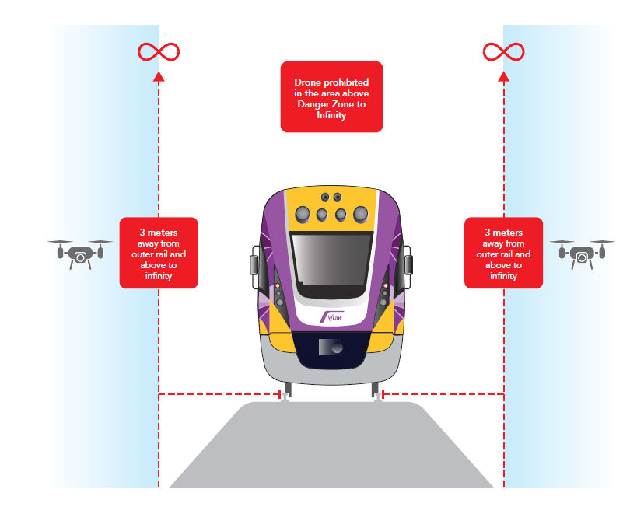
Example Flight path
